TECHNICAL PROPOSAL

Intelligent Shield
Managed Vision as a Service Platform
AI Powered Surveillance for High Stakes Security Operations
Field | Detail
Client | DEE Corp International
Prepared by | Aurora Robotics
Project | Intelligent Shield MVaaS Platform
Engagement Type | Design, Build, Integration, Deployment, Training and Go Live Support
Recommended Edge Platform | Raspberry Pi 5 + Hailo 8L (minimum) to NVIDIA Jetson Orin NX (maximum)
Scope of Work | Software Platform, AI Models, Integration (hardware procured by client)
Software Service Fee | ₦10,000,000 (fixed, all inclusive)
Estimated Delivery Timeline | 2 to 3 Months
Version | 1.0
Status | Confidential
Date | April 2026

0. Table of Content
0. Table of Content 2
1. Executive Summary 4
2. Why Intelligent Shield, Not Traditional CCTV 5
2.1 Operational Advantages 5
2.2 Commercial Advantages 5
2.3 Compliance and Governance Advantages 5
2.4 Strategic Rationale 6
2.5 The Core Argument: Why Invest Now 6
3. Platform Overview 7
3.1 Recommended Hardware Stack 7
3.1.1 Edge Platform: Minimum and Maximum Recommended 7
3.1.2 Network Layer (Common to Both Tiers) 8
3.1.3 Power Continuity (Common to Both Tiers) 9
3.1.4 Camera Layer (Common to Both Tiers) 9
3.1.5 Escalation Layer (Common to Both Tiers) 9
3.2 Edge to Centre Architecture 10
Edge Responsibilities 10
Central Responsibilities 10
3.3 Design Principles 10
4. Module Breakdown and Feasibility 11
4.1 Identity Layer 11
4.2 Spatial Layer 11
4.3 Temporal Layer 12
4.4 Behavioural Layer 12
4.5 Fusion Logic and Alert Decisioning 12
5. System Architecture 13
5.1 System Block Diagram 13
5.2 System Flowchart 15
5.3 Software Stack Overview 17
5.4 Data Flow and Event Lifecycle 17
5.5 Key Technical Risks and Mitigations 18
6. Phased Delivery Plan 19
Phase 1: Discovery, Site Survey and Solution Design | 2 to 3 weeks 19
Phase 2: Platform Build and Integration | 3 to 4 weeks 19
Phase 3: Site Deployment and Commissioning | 2 to 3 weeks 20
Phase 4: Baseline Observation, Tuning and Training | 2 to 3 weeks 20
Phase 5: Production Go Live and Hypercare | 1 to 2 weeks 20
7. Software Investment Summary 21
7.1 Fixed Software Service Fee 21
7.2 What the Fee Covers 21
7.3 What the Fee Does Not Cover 22
7.4 Hardware Recommendation Posture 23
7.5 Ongoing Platform Operation 23
8. Team Structure 24
9. Project Milestones and Gate Reviews 25
10. Why Aurora Robotics 26
10.1 Realistic Delivery Posture 26
10.2 Full Stack Systems Integration 26
10.3 Honest Technical Scoping 26
10.4 Commercial Clarity 26
10.5 Multi Site Platform by Design 26
10.6 Built for Nigerian Infrastructure Realities 27

1. Executive Summary
Aurora Robotics proposes Intelligent Shield, an edge first, AI powered Managed Vision as a Service (MVaaS) platform that converts traditional CCTV infrastructure into an active security intelligence system. It is built for high stakes operations requiring real time detection, fast operator alerts, structured escalation, and audit ready records.

The system runs AI inference locally at each site on a client procured edge platform. Aurora Robotics recommends two validated hardware tiers: a Raspberry Pi 5 plus Hailo 8L configuration for standard sites (minimum) and an NVIDIA Jetson Orin NX configuration for high density sites (maximum). Edge inference, rather than cloud routing, delivers low latency, resilience during outages, and a practical fit for Nigerian infrastructure conditions.
The platform operates across four integrated intelligence layers:
- Identity: distinguishes authorised, unknown, and watchlisted persons via face recognition.
- Spatial: detects zone intrusion, tripwire breaches, loitering, and movement violations.
- Temporal: applies time based rules so the same activity is judged differently by schedule.
- Behavioural: identifies falls, aggression, prolonged loitering, and unusual congregation.

All four layers feed a fusion engine that scores and ranks events before any alert is raised, eliminating single signal noise and improving operator trust.
Aurora Robotics will design, build, integrate, deploy, train, and support the software platform through go live. Hardware is recommended by Aurora Robotics but procured and installed by the client. Proposed delivery window: 2 to 3 months. Fixed software service fee: ₦10,000,000, covering the full platform build and deployment support.

2. Why Intelligent Shield, Not Traditional CCTV
Conventional CCTV records footage but does not decide what matters, rank urgency, or coordinate response. Operators suffer attention fatigue monitoring multiple screens, and most incidents are only discovered after the fact. Intelligent Shield redesigns surveillance as an event driven system: the platform filters and surfaces what matters; the human confirms and acts.

2.1 Operational Advantages
- Faster detection: AI classifies events on site in near real time.
- Greater coverage per operator: alerts are pushed; no need to watch every feed continuously.
- Faster investigations: events carry metadata and short clips; search replaces manual DVR scrubbing.
- Local resilience: detection continues during internet outages; events sync on reconnection.
- Structured escalation: siren, guard dispatch, and client notification are built into the workflow.
- Measurable service: mean time to alert, confirmation rate, and false positive rate are trackable.

2.2 Commercial Advantages
The platform scales by reusing software, rules, and dashboards across sites, not by adding headcount. Each new site is a configuration and deployment task. This enables a recurring managed service model with stronger margins than a one time equipment transaction.

2.3 Compliance and Governance Advantages
Biometric enrolment is access controlled; raw images are not retained, only encrypted embeddings. All event handling is policy governed with full audit trails, aligning with Nigerian data protection requirements.

2.4 Strategic Rationale
Intelligent Shield moves DEE Corp International up the value chain, packaging proactive intelligence, central management, and measurable reporting into a premium managed service offer that commands recurring revenue conventional guarding cannot match.

2.5 The Core Argument: Why Invest Now
- The ecosystem is ready: edge AI hardware, lightweight models, and secure tunnel technologies are mature and field tested.
- The economics work: Raspberry Pi 5 plus Hailo 8L delivers enterprise grade AI compute at a fraction of traditional appliance cost.
- The market gap is real: very few providers can deploy a coherent AI surveillance platform with analytics, workflow, and governance.
- Client expectations have shifted: enterprise buyers now demand early awareness, structured alerts, and client facing visibility tools.

3. Platform Overview
Intelligent Shield is a modular edge to centre software platform. The edge gateway runs all video analytics and rule logic locally. Events are forwarded over an encrypted WireGuard tunnel to the central platform for coordination, dashboards, and client reporting. Raw video never leaves the site in normal operation.
Aurora Robotics delivers the software platform, AI models, rule engines, dashboards, and integration services. Aurora Robotics recommends the preferred hardware stack but does not supply, procure, or install hardware. Two validated reference configurations are specified below so the client can choose the tier appropriate to each site.

3.1 Recommended Hardware Stack
The table below specifies the two validated edge platform configurations. The minimum configuration is suited to standard 2 to 8 camera sites; the maximum configuration is suited to high density sites running 12 or more concurrent streams or requiring headroom for advanced behavioural analytics. Both tiers run the identical Aurora Robotics software image.

3.1.1 Edge Platform: Minimum and Maximum Recommended
Component / Spec | Minimum (Raspberry Pi 5 + Hailo 8L) | Maximum (NVIDIA Jetson Orin NX 16GB)
Edge Platform | Raspberry Pi 5 (8GB) + Hailo 8L | NVIDIA Jetson Orin NX 16GB
AI Compute | 13 TOPS INT8 (Hailo 8L accelerator) | Up to 157 TOPS (MAXN unbounded mode)
CPU | Quad core Arm Cortex A76 at 2.4 GHz | 8 core Arm Cortex A78AE
Memory | 8 GB LPDDR4X | 16 GB LPDDR5
Storage | NVMe SSD 512 GB (encrypted) | NVMe SSD 1 TB (AES 256 encrypted)
Camera Capacity (1080p H.265) | 2 to 6 concurrent streams | 12 to 18 concurrent streams
Typical Inference Latency | Approx. 15 ms per frame (YOLOv8s INT8) | Approx. 3.2 ms per frame (YOLOv8s INT8)
Power Draw (typical) | 7 to 15 W | 10 to 25 W
Network | Gigabit Ethernet + LTE failover (USB) | Dual Gigabit Ethernet + LTE failover
Operating System | Ubuntu Server 22.04 LTS (Aurora image) | Ubuntu 22.04 LTS (Aurora image, JetPack)
Secure Boot | UEFI + signed bootloader | NVIDIA fuse locked, signed firmware
Secure Transport | WireGuard VPN | WireGuard VPN (kernel space)
Recommended Use | Standard commercial sites, retail, offices | High density campuses, critical infrastructure, premium tier

3.1.2 Network Layer (Common to Both Tiers)
Component | Recommended Specification | Purpose
PoE+ Managed Switch | 8 port Gigabit, 802.3at, sufficient budget for camera count | Powers cameras and provides structured LAN
Structured Cabling | Cat6 (weatherproof where required) | Gigabit transport between cameras, switch, and gateway
LTE Failover Modem | 4G LTE Cat.4 or higher | Automatic backup when primary link fails

3.1.3 Power Continuity (Common to Both Tiers)
Component | Recommended Specification | Purpose
UPS | Line interactive, sized for 8 hour autonomy per site | Bridges outages; supports graceful shutdown
Optional Solar | Hybrid solar + LiFePO4 battery bank | For sites with prolonged grid unavailability

3.1.4 Camera Layer (Common to Both Tiers)
Component | Recommended Specification | Purpose
IP Cameras | ONVIF, 1080p at 30fps, H.265, PoE, IR, IP67 | Primary video source for the analytics pipeline
Sensor | Sony IMX335 class low light sensor or equivalent | Reliable performance in mixed light conditions
Mounts | Site appropriate mounts, glands, pole adapters | Physical installation and cable management

3.1.5 Escalation Layer (Common to Both Tiers)
Component | Recommended Specification | Purpose
Relay Interface | 4 channel opto isolated relay, SPDT, 5A at 250VAC | Drives siren, strobe, gate, or alarm panel
Siren / Strobe | 12V 120 dB outdoor weatherproof siren plus strobe | Audible and visual deterrent
Isolated Supply | Dedicated 12V PSU for siren channel | Prevents brownout during siren activation
Note: the specifications above are recommendations. Aurora Robotics validates site hardware against these baselines during the Phase 1 site survey but does not procure, supply, install, or warrant physical hardware. Hardware is sourced and commissioned by the client or a third party systems integrator of the client's choice.

3.2 Edge to Centre Architecture

Edge Responsibilities
RTSP stream ingestion; video decoding (GStreamer / FFmpeg); AI inference on the recommended edge accelerator (Hailo 8L or NVIDIA Jetson); rule execution across all four layers; event fusion, scoring, and local clip storage (encrypted NVMe); relay activation for physical deterrence; site heartbeat and diagnostics.

Central Responsibilities
Multi site alert intake; event logging (PostgreSQL); clip storage (MinIO); real time dashboard delivery via Redis and MQTT; role based access control; fleet health monitoring; configuration management; audit logging and client reporting.

3.3 Design Principles
- Edge first inference: analytics run on site; the centre coordinates and reports.
- Structured events, not raw footage: alerts carry metadata and clip references only.
- Fusion over single signal trust: no individual layer triggers escalation alone.
- Operator in the loop: the system proposes; the human confirms.
- Graceful degradation: sites keep detecting if the internet, central service, or a single camera fails.

4. Module Breakdown and Feasibility
The platform comprises four intelligence layers that run independently but converge in the fusion engine for alert decisioning.

4.1 Identity Layer
Detects and recognises faces at designated cameras. A two step process: face detection flags human presence, then face recognition converts the detected face into an encrypted embedding compared against enrolled vectors.
- Enrolment captures reference images with explicit consent; only embeddings are stored, not raw images.
- Useful for: staff access validation, unknown person flagging after hours, watchlist matching, repeat intruder detection.
- Performance depends on camera angle, lighting, and subject distance. Deployed at suitable entry points, not universally across all cameras.

4.2 Spatial Layer
Determines where objects are and whether their presence or movement violates site rules. Supports virtual tripwires, zone entry, stay zone violations, occupancy thresholds, loitering duration, directional filters, and human / vehicle / animal classification.
Uses a YOLOv8 class detection model (compiled to the chosen accelerator) plus a multi object tracker for trajectory analysis. Zones and tripwires are drawn as polygons or line segments in the operator configuration interface.

4.3 Temporal Layer
Applies schedule aware rules so identical activity is judged differently by time of day, day of week, or calendar event. Supports business hour schedules, after hours restrictions, holiday calendars, Active Defence night windows, and planned event relaxation.
Runs as a deterministic rule engine; no inference required. Schedules are defined centrally and enforced locally, so time based logic persists even during central link outages.

4.4 Behavioural Layer
Identifies what a person is doing via pose estimation (skeletal keypoints). Supported classes include fall / prone position, aggressive motion, extended loitering, unusual congregation, and safety related posture events.
Pose inference runs selectively, only for human detections inside defined zones, to preserve real time throughput. Aurora Robotics recommends starting with high value, lower ambiguity classes (falls, loitering, clear aggression) and expanding based on pilot evidence.

4.5 Fusion Logic and Alert Decisioning
The fusion engine receives identity status, spatial status, temporal status, behavioural status, and confidence scores for each detected subject. It outputs a binary decision (alert or monitor), a severity tier (informational, warning, critical), a 3 to 5 second verification clip, structured metadata, and a recommended escalation path.
Why this matters: an unknown face alone is not a threat. An unknown face crossing a restricted zone at 3 AM with an aggressive pose pattern is. The fusion engine is what turns raw AI output into actionable security judgement.

5. System Architecture

5.1 System Block Diagram
Site hardware (cameras, PoE switch, UPS, LTE modem, relay outputs) → Edge Gateway (client procured, Raspberry Pi 5 + Hailo 8L or NVIDIA Jetson Orin NX, running the Aurora Robotics software image with four layer analytics and local storage) → Secure WireGuard Tunnel → Central Logic Engine (event ingestion, rules engine, PostgreSQL, MinIO, Redis, MQTT) → Operator Command Centre and Client Access.

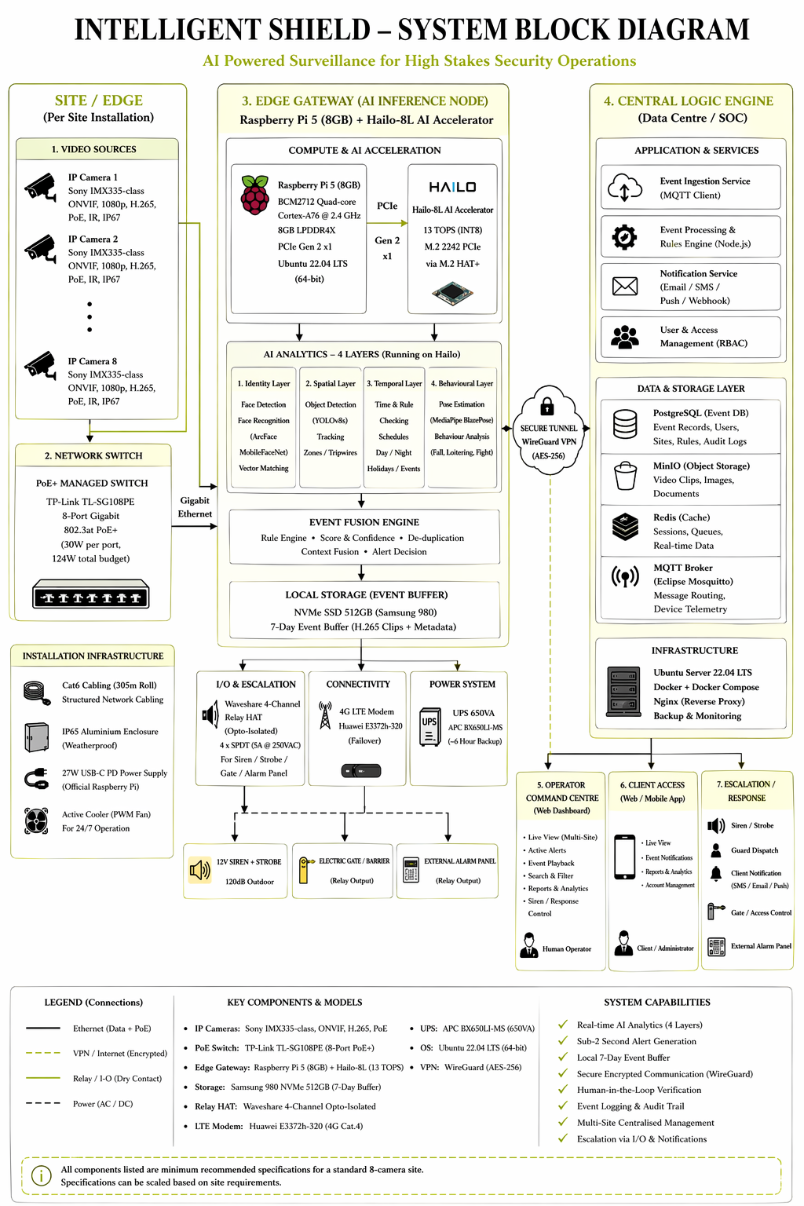

5.2 System Flowchart
Camera captures video → PoE switch delivers power and data → edge gateway decodes stream → AI analytics run across four layers on the edge accelerator → fusion engine scores signals → if security event: alert created with clip and metadata, transmitted over WireGuard to central engine → operator reviews and confirms or rejects → confirmed: escalation workflow fires (siren, guard, client notification) → all events logged for audit.

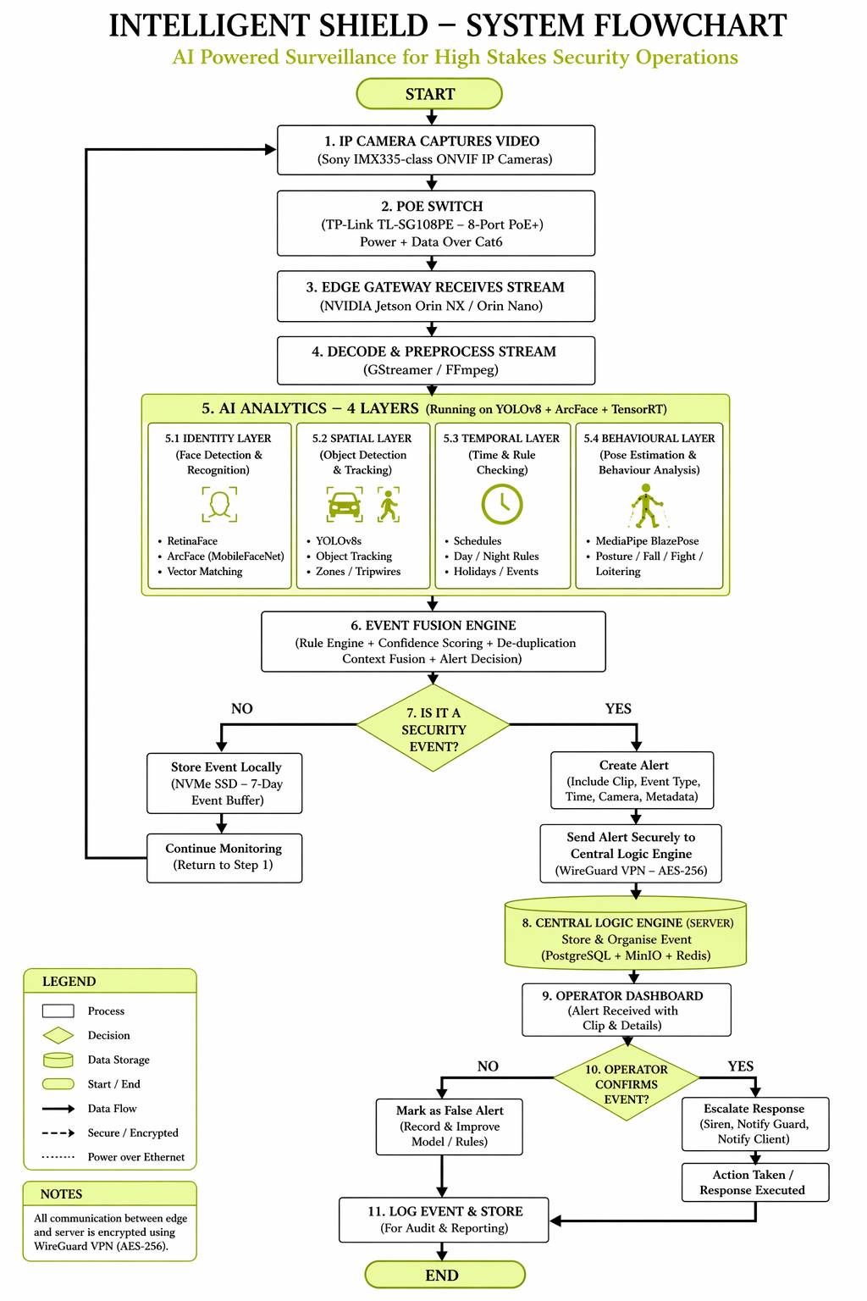

5.3 Software Stack Overview
Layer | Key Components
Perception | YOLOv8 (object detection), ArcFace (face recognition), MediaPipe BlazePose, multi object tracker, GStreamer / FFmpeg, HailoRT
Rule and Fusion | Identity rule checks, spatial zone / tripwire logic, temporal schedule engine, behavioural classifier, weighted confidence scoring
Event Orchestration | Alert creation with metadata plus clip, severity ranking, message bus routing, email / SMS / push / webhook notifications
Data | PostgreSQL (events), MinIO (clips), Redis (cache / sessions), MQTT broker (telemetry)
Interface | Operator Command Centre (web), Client PWA (web / mobile), admin configuration tools
Monitoring | Prometheus plus Grafana (metrics), structured logging, device heartbeat, fleet uptime tracking
Release | Version pinned edge images, staged rollout, blue/green deployment, automatic rollback

5.4 Data Flow and Event Lifecycle
Capture → Ingest → Perceive (edge accelerator) → Interpret (rule plus fusion layer) → Decide → Persist locally (encrypted NVMe) → Transport (WireGuard) → Ingest centrally (PostgreSQL plus MinIO) → Route (MQTT to dashboard) → Review (operator) → Act (escalation) → Learn (rejection feedback) → Archive (audit retention).

5.5 Key Technical Risks and Mitigations
Risk | Mitigation
Power interruption | UPS sized per site; graceful restart design; optional solar plus LiFePO4 for critical sites.
Internet disruption | Edge continues operating; events buffered locally; LTE failover re-establishes WireGuard automatically.
False positive overload | Passive baseline period calibrates thresholds before live alerting; fused scoring and operator confirmation loop control noise.
Hardware / runtime compatibility | Version pinned edge images; updates staged via test environment; blue/green deployment with auto rollback.
Camera placement limits | Site survey before installation; scene specific tuning and acceptance testing prior to go live.
Data handling | RBAC on all access; no raw biometric images retained; WireGuard encryption end to end; full audit trails.
Accelerator saturation | Selective inference per subject (not per frame per camera); per site analytics profiles tuned during baseline.
Scope inflation | Written change control process; additions trigger explicit timeline and cost impact review.

6. Phased Delivery Plan
Aurora Robotics proposes a 2 to 3 month delivery schedule covering design, build, deployment, tuning, training, and controlled go live. Each phase ends with a milestone gate review and written sign off before the project advances.

Phase 1: Discovery, Site Survey and Solution Design | 2 to 3 weeks
- Stakeholder alignment workshop; operational requirements review.
- Site survey: power, network, camera positions, environmental factors.
- Camera location planning; PoE budget and UPS sizing.
- Compliance and escalation workflow review.
- Final solution design, bill of materials, and risk register.
Key deliverables: site survey report; zone and camera plan; architecture note; bill of materials; risk and dependency register.

Phase 2: Platform Build and Integration | 3 to 4 weeks
- Edge master image: hardened OS, pinned Hailo driver, container runtime, analytics services.
- Central platform: PostgreSQL, MinIO, Redis, MQTT broker, orchestration services.
- AI model compilation to the target edge accelerator (Hailo RT or NVIDIA TensorRT); rule engine and fusion logic configuration.
- WireGuard hub deployment; keypair generation; access control lists.
- Operator dashboard and client PWA baseline; observability setup (Prometheus / Grafana).
Key deliverables: configured edge master image; configured central environment; staging dashboard; rule set and alert categories; test environment validation report.

Phase 3: Site Deployment and Commissioning | 2 to 3 weeks
- Hardware installation.
- Switch configuration, PoE verification, camera alignment per zone plan.
- Edge node deployment and registration; WireGuard key provisioning.
- Relay and escalation path testing; LTE failover test; passive model activation.
Key deliverables: installed pilot site; field acceptance checklist; device registration record; physical escalation test record; site configuration export.

Phase 4: Baseline Observation, Tuning and Training | 2 to 3 weeks
- Passive monitoring: system detects without generating live alerts; engineers calibrate thresholds.
- False positive review; rule refinement; operator workflow rehearsal with shadow alerts.
- User training for operators (minimum two cohorts) and administrators.
- Documentation preparation.
Key deliverables: baseline tuning summary; final alert thresholds; training completion records; operator and administrator handbooks; go live readiness review.

Phase 5: Production Go Live and Hypercare | 1 to 2 weeks
- Staged activation of live alerting (by severity and category).
- Active monitoring; rapid issue resolution with engineering on standby.
- Post go live review with stakeholders; formal handover of documentation and credentials.
Key deliverables: go live report; hypercare support summary; final handover package (runbooks, credentials, escalation contacts); post implementation review minutes.

7. Software Investment Summary
Aurora Robotics is a software and platform provider. The engagement is priced as a single fixed software service fee. Hardware is recommended by Aurora Robotics (see Section 3.1) but procured, installed, and owned by the client. There is no hardware mark up, no procurement margin, and no installation labour component in the Aurora Robotics fee.

7.1 Fixed Software Service Fee
TOTAL SOFTWARE SERVICE FEE
₦ 10,000,000
Fixed, all inclusive, exclusive of hardware

7.2 What the Fee Covers
Workstream | Included in the ₦10,000,000 Fee
Discovery and Architecture | Stakeholder workshop, requirements capture, site survey, solution design, risk register.
Edge Platform Software Build | Aurora Master OS Image, hardened Linux runtime, container stack, edge analytics services, validated for both minimum and maximum recommended hardware tiers.
AI Model Integration | Object detection, face recognition, pose estimation model selection, compilation, and tuning for the target edge accelerator.
Rule Engine and Fusion Logic | Identity, spatial, temporal, and behavioural rule definition; fusion confidence scoring; alert decisioning.
Central Platform Setup | PostgreSQL, MinIO, Redis, MQTT broker, orchestration services, WireGuard hub, observability stack.
Operator and Client Interfaces | Command Centre dashboard and Client PWA baseline; role based access control; configuration tooling.
Deployment Support | Pilot site commissioning support, baseline tuning, threshold calibration, LTE failover and escalation path testing.
Training and Documentation | Two operator cohorts plus administrator training; operator and administrator handbooks; runbooks and handover package.
Go Live and Hypercare | Staged activation of live alerting; 1 to 2 week hypercare period with engineering on standby.

7.3 What the Fee Does Not Cover
The Aurora Robotics fee is a software and platform service fee. The following items are the client's responsibility and are not included:
- Physical hardware: cameras, edge compute devices, PoE switches, UPS units, LTE modems, cabling, enclosures, siren or relay hardware.
- Installation and commissioning labour at the site, including mounting, cabling, and power distribution.
- Internet service, LTE airtime, and datacentre or cloud hosting fees.
- Statutory approvals, NDPC registration fees, or any levy payable to third parties.
- Ongoing support contracts, preventive maintenance, and hardware refresh after implementation.
Aurora Robotics is pleased to recommend trusted hardware suppliers and installation partners, but does not act as reseller, broker, or principal for any hardware transaction.

7.4 Hardware Recommendation Posture
The hardware specifications in Section 3.1 are validated reference configurations. The client may procure either the minimum recommended tier (Raspberry Pi 5 plus Hailo 8L) or the maximum recommended tier (NVIDIA Jetson Orin NX 16GB) per site. Both tiers run the identical Aurora Robotics software image and receive identical software support. Aurora Robotics reviews the client's hardware selection during the Phase 1 site survey and confirms compatibility before the platform build begins.

7.5 Ongoing Platform Operation
Following implementation, optional recurring services may include datacentre or cloud hosting; software maintenance and security patches; operational support; preventive site visits; extended analytics tuning; and hardware refresh coordination. A separate managed support proposal can be provided after going live and is not part of the ₦10,000,000 fee.

8. Team Structure
Each function below must be represented for the delivery to succeed. Roles may be combined on smaller deployments. Expected core team: 4 to 6 engineers plus project manager and compliance support.
Role | Responsibilities
Project Manager | Governance, planning, stakeholder communication, milestone control. Single accountability point for delivery.
AI / Computer Vision Engineer | Model selection and compilation to Hailo 8L, inference validation, fusion logic, threshold tuning. Owns perception and fusion layers.
Embedded Systems / Linux Engineer | Raspberry Pi 5 edge image, device hardening, Hailo driver integration, relay and GPIO. Owns edge platform reliability.
Backend / Platform Engineer | Central services, database, object storage, event routing, API, authentication, monitoring. Owns central platform.
Frontend / UX Engineer | Operator dashboard, client PWA, verification pane usability. Owns the operator interaction model.
Field / Network Engineer | Site survey, connectivity design, camera positioning, PoE and UPS sizing, on site acceptance.
Compliance / Governance Support | Data handling review, policy alignment, role design, privacy documentation.

9. Project Milestones and Gate Reviews
Each milestone requires written sign off before the project advances. Gate reviews protect quality, maintain scope discipline, and keep both parties aligned throughout implementation.
# | Milestone | Exit Criteria
M1 | Design Approved | Requirements agreed and documented; site survey complete; architecture signed off; bill of materials approved; assumptions register acknowledged.
M2 | Platform Build Complete | Edge master image built and verified for both recommended tiers; AI models compiled for the target accelerator; central environment running; WireGuard hub operational; staging dashboard reachable.
M3 | Site Installation Complete | Hardware installed and networked; cameras aligned per zone plan; field devices registered with central platform; LTE failover verified; relay outputs physically tested.
M4 | Pilot Commissioned | Analytics pipeline live against cameras; alert path tested end to end in passive mode; event recording and review functional; central dashboard showing real site data.
M5 | Baseline and Tuning Complete | Passive monitoring reviewed; thresholds calibrated to observed environment; false alert controls at agreed tolerance; category activation plan signed off.
M6 | Go Live Ready | Two operator cohorts trained; operational workflow approved by DEE Corp International; documentation delivered; hypercare plan agreed.
M7 | Hypercare Closed | Live period stabilised; material issues resolved or remediation logged; final handover accepted; post implementation review completed.

10. Why Aurora Robotics

10.1 Realistic Delivery Posture
The 2 to 3 month timeline is deliberate. Platform quality depends on disciplined integration, field validation, baseline tuning, and operator readiness, not speed of assembly. A deployment that works reliably on day one is worth far more than one built quickly but unstable.

10.2 Full Stack Systems Integration
The value of Intelligent Shield is in how cameras, edge compute, analytics, dashboards, rules, operators, and escalation workflows are made to work together. Aurora Robotics focuses on that software integration challenge. Two validated hardware tiers (Raspberry Pi 5 plus Hailo 8L as minimum, NVIDIA Jetson Orin NX as maximum) are supported by the same Aurora Master Image, so the client chooses the cost and capability point per site without switching software stacks.

10.3 Honest Technical Scoping
Aurora Robotics scopes capabilities to what evidence supports: identity recognition is deployed at suitable cameras only, not universally; behavioural analytics are staged by reliability class; fusion logic governs every alert so no single signal is trusted alone. High value analytics are deployed first; expansion follows pilot evidence.

10.4 Commercial Clarity
Aurora Robotics is strictly a software and platform provider. The ₦10,000,000 fee is a fixed, all inclusive software service fee with no hardware mark up, procurement margin, or installation labour component. The client sources hardware directly using the validated recommendations in Section 3.1, keeping hardware scope, supplier choice, and procurement economics under client control.

10.5 Multi Site Platform by Design
The central logic engine is built for multi-site operation from day one. Adding a new site is a configuration and deployment task, not a redesign. Intelligent Shield is a scalable platform foundation, not a single site installation.

10.6 Built for Nigerian Infrastructure Realities
Grid inconsistency and variable internet quality are treated as design constraints, not exceptions. Local edge autonomy, LTE failover, UPS sizing, and offline event buffering are all first class features, not afterthoughts.

Ready to Move Forward?
Contact Aurora Robotics to schedule a technical deep dive and receive a formal fixed price quotation.
hello@aurora-robotics.com | www.aurora-robotics.com/support
RUN INTO THE UNKNOWN — FORZA AURORA

